**ANGULAR FRONTEND ASSIGNMENT**

**NEHA SHARMA**

[**http://localhost:4200/**](http://localhost:4200/)

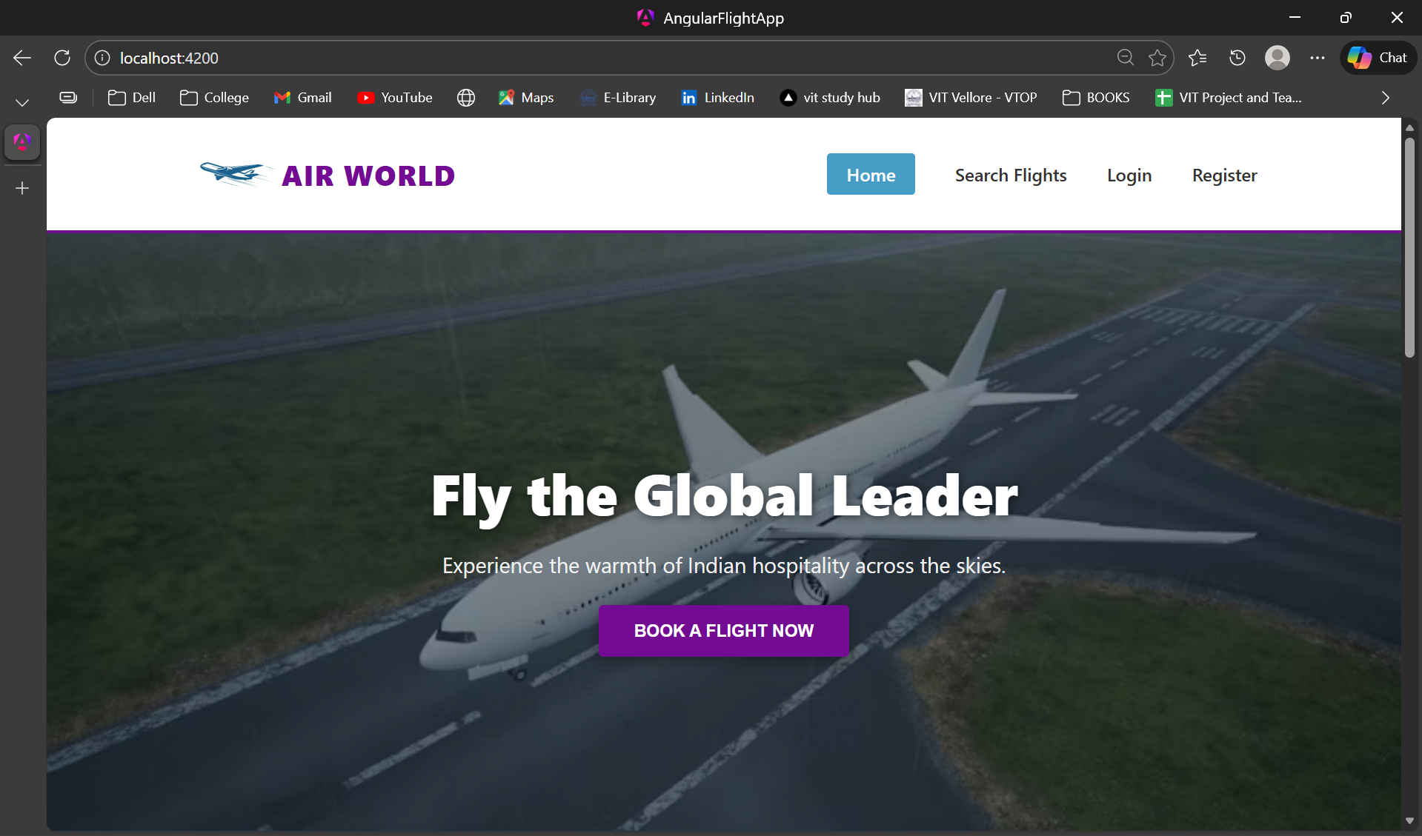

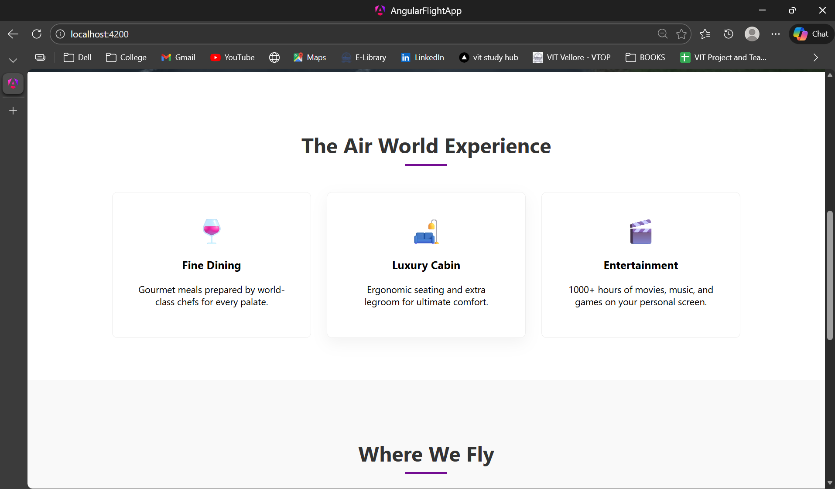

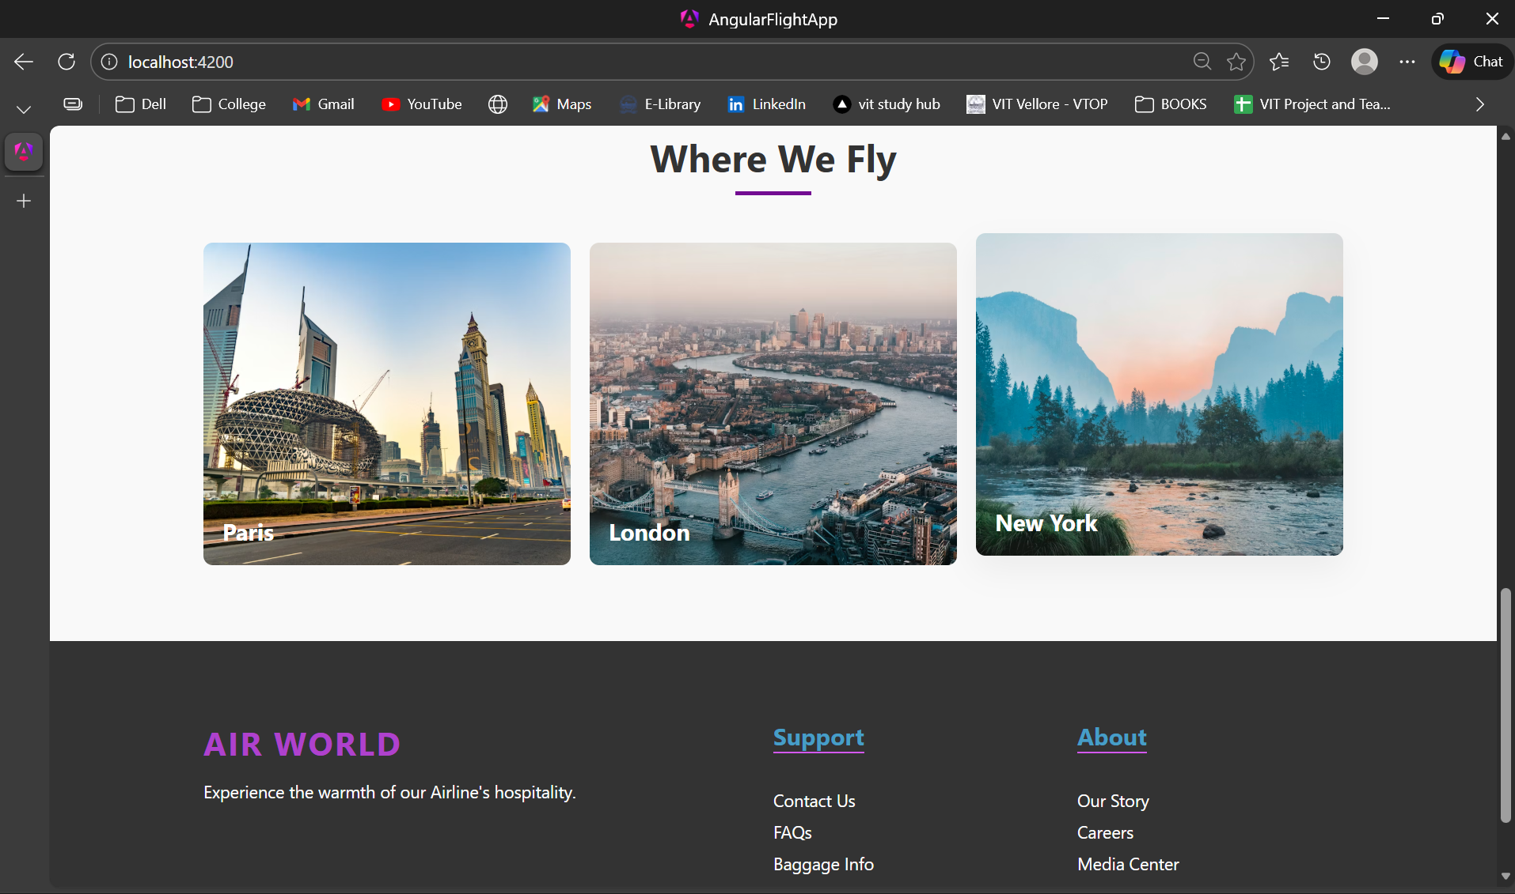

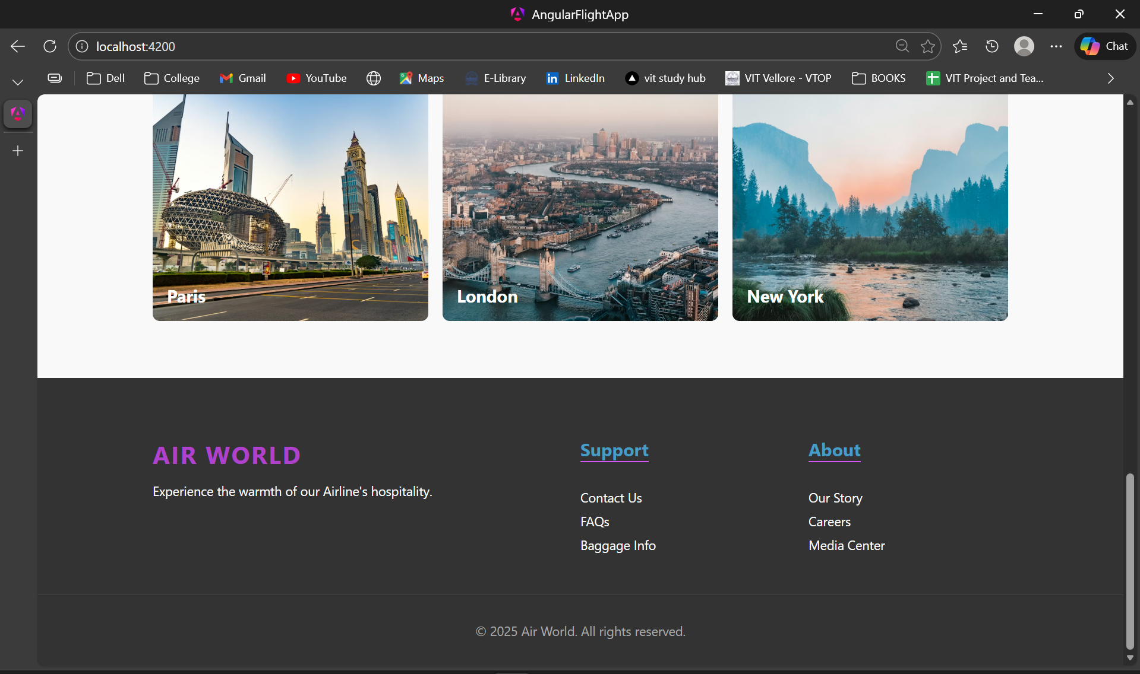

[**http://localhost:4200/search**](http://localhost:4200/search)

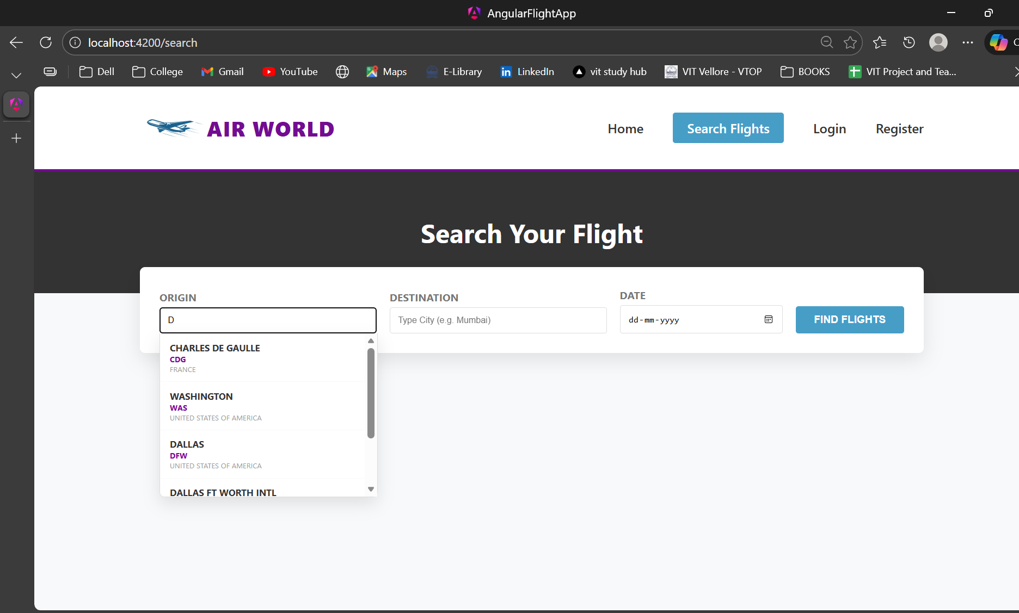

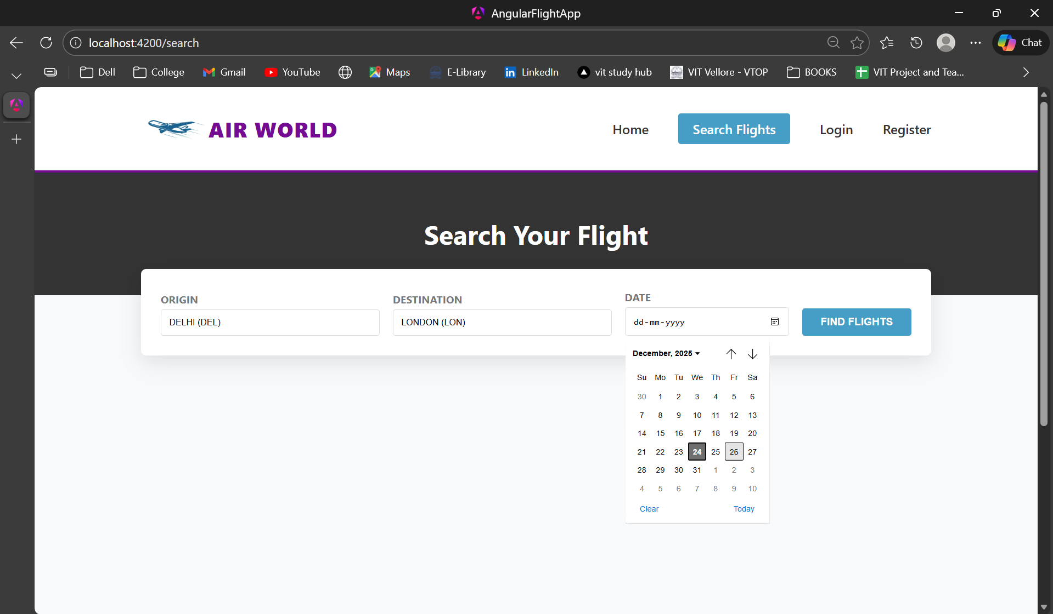

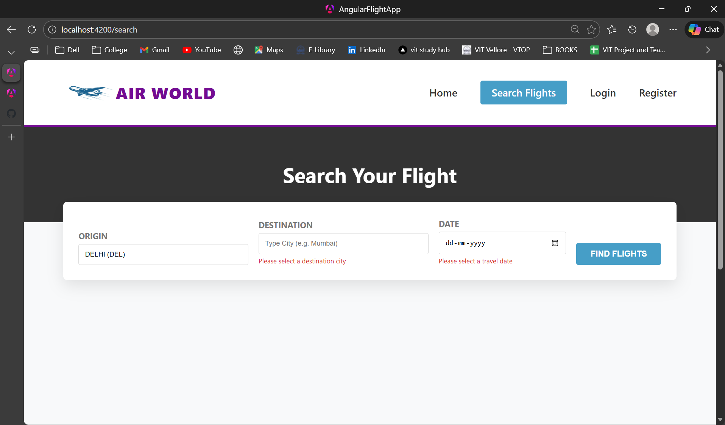

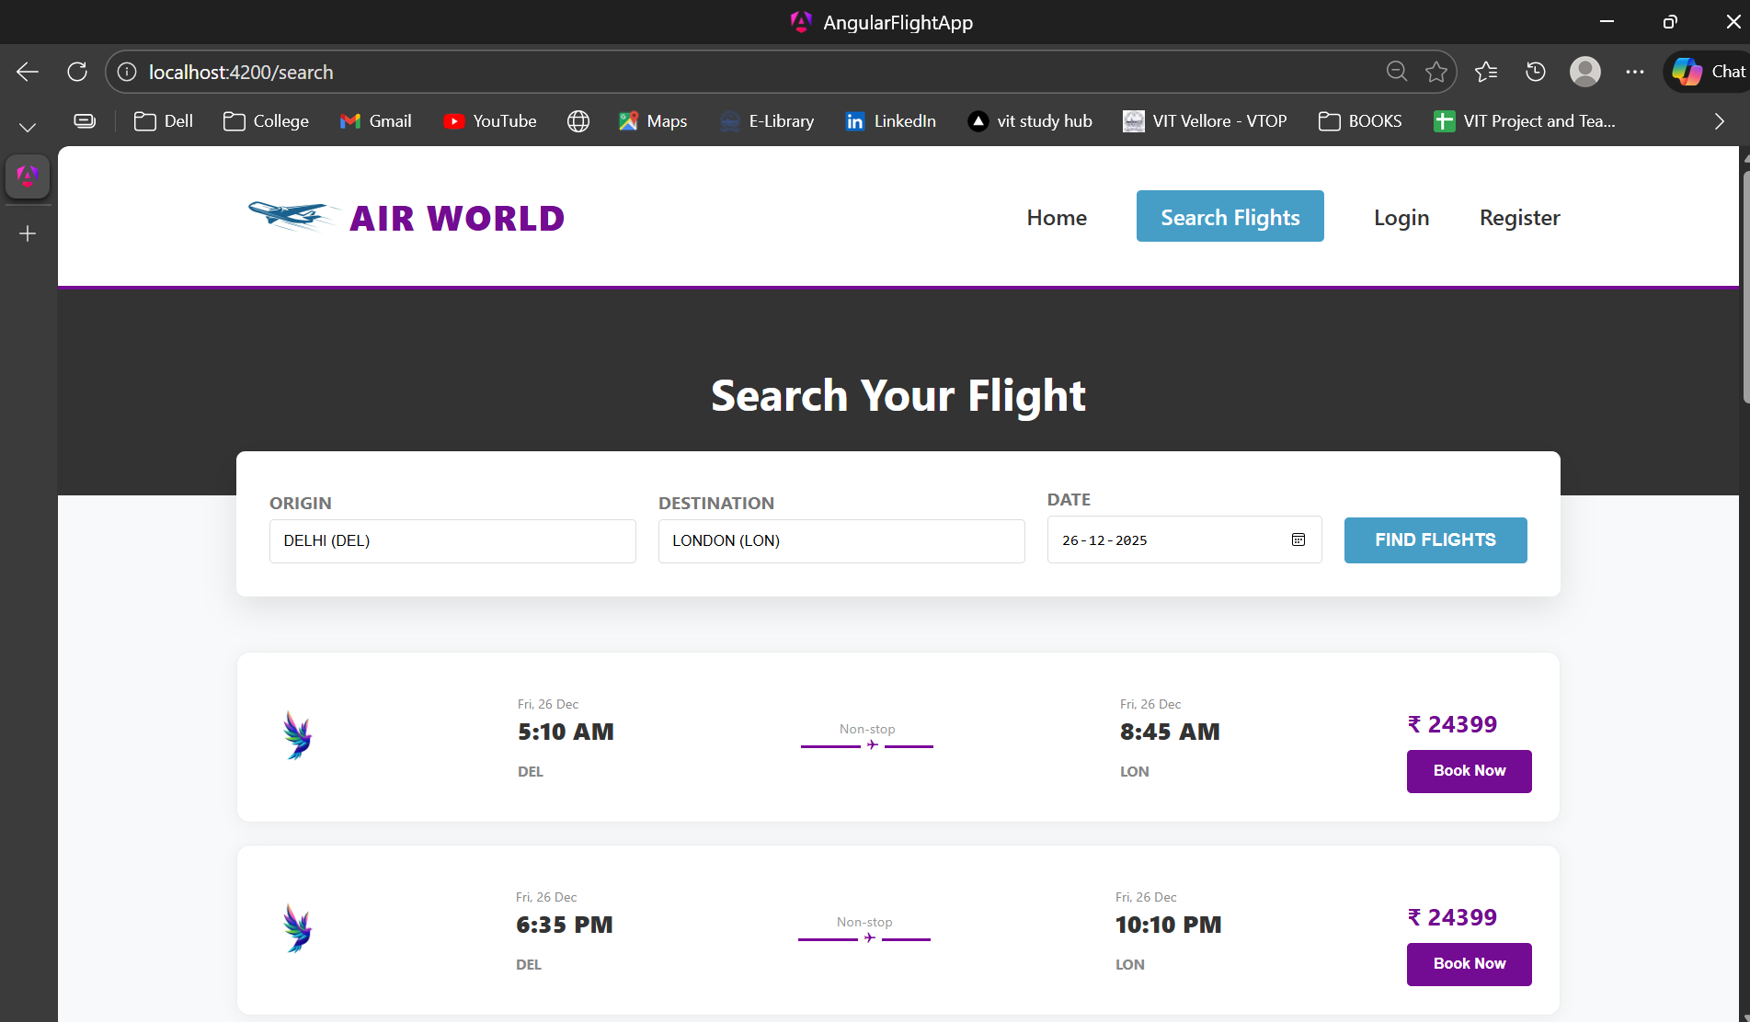

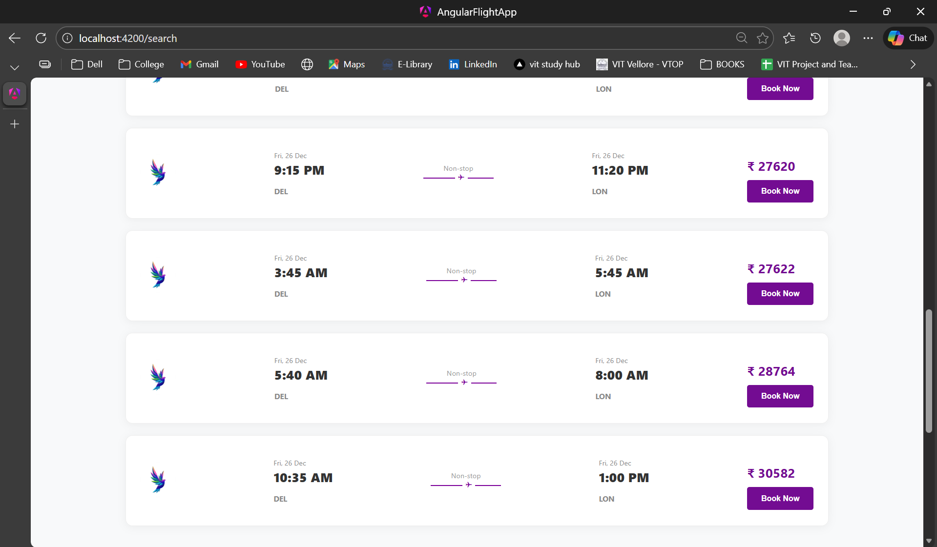

[**http://localhost:4200/register**](http://localhost:4200/register)

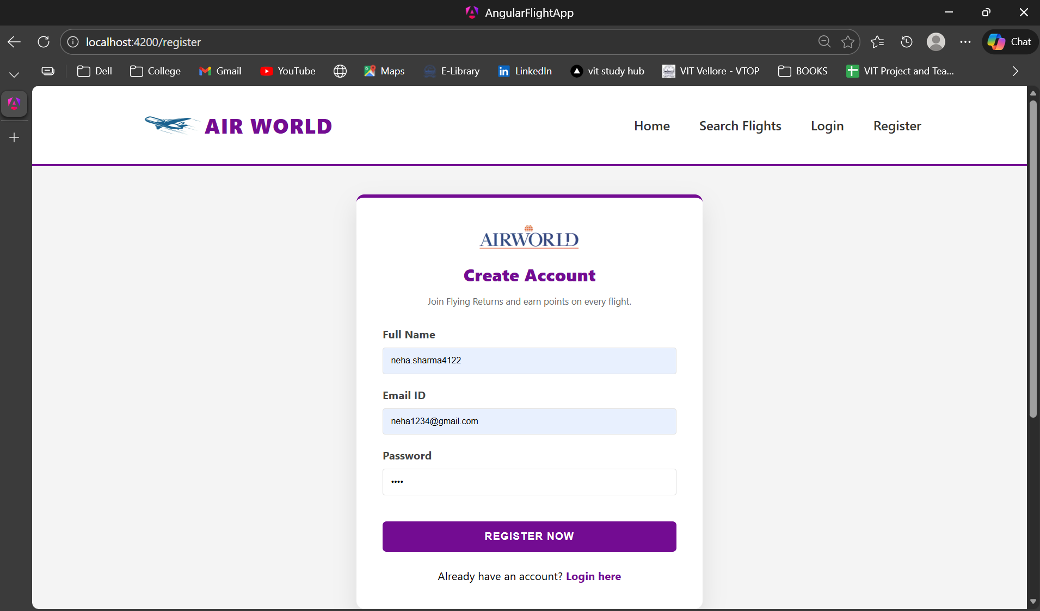

**On clicking “Register Now”:**

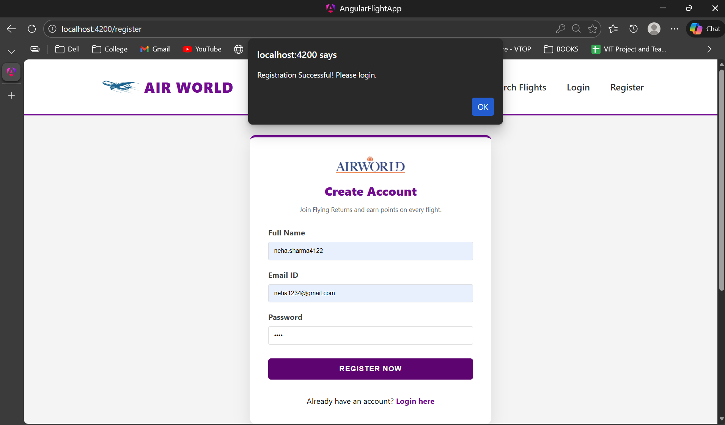

[**http://localhost:4200/login**](http://localhost:4200/login)

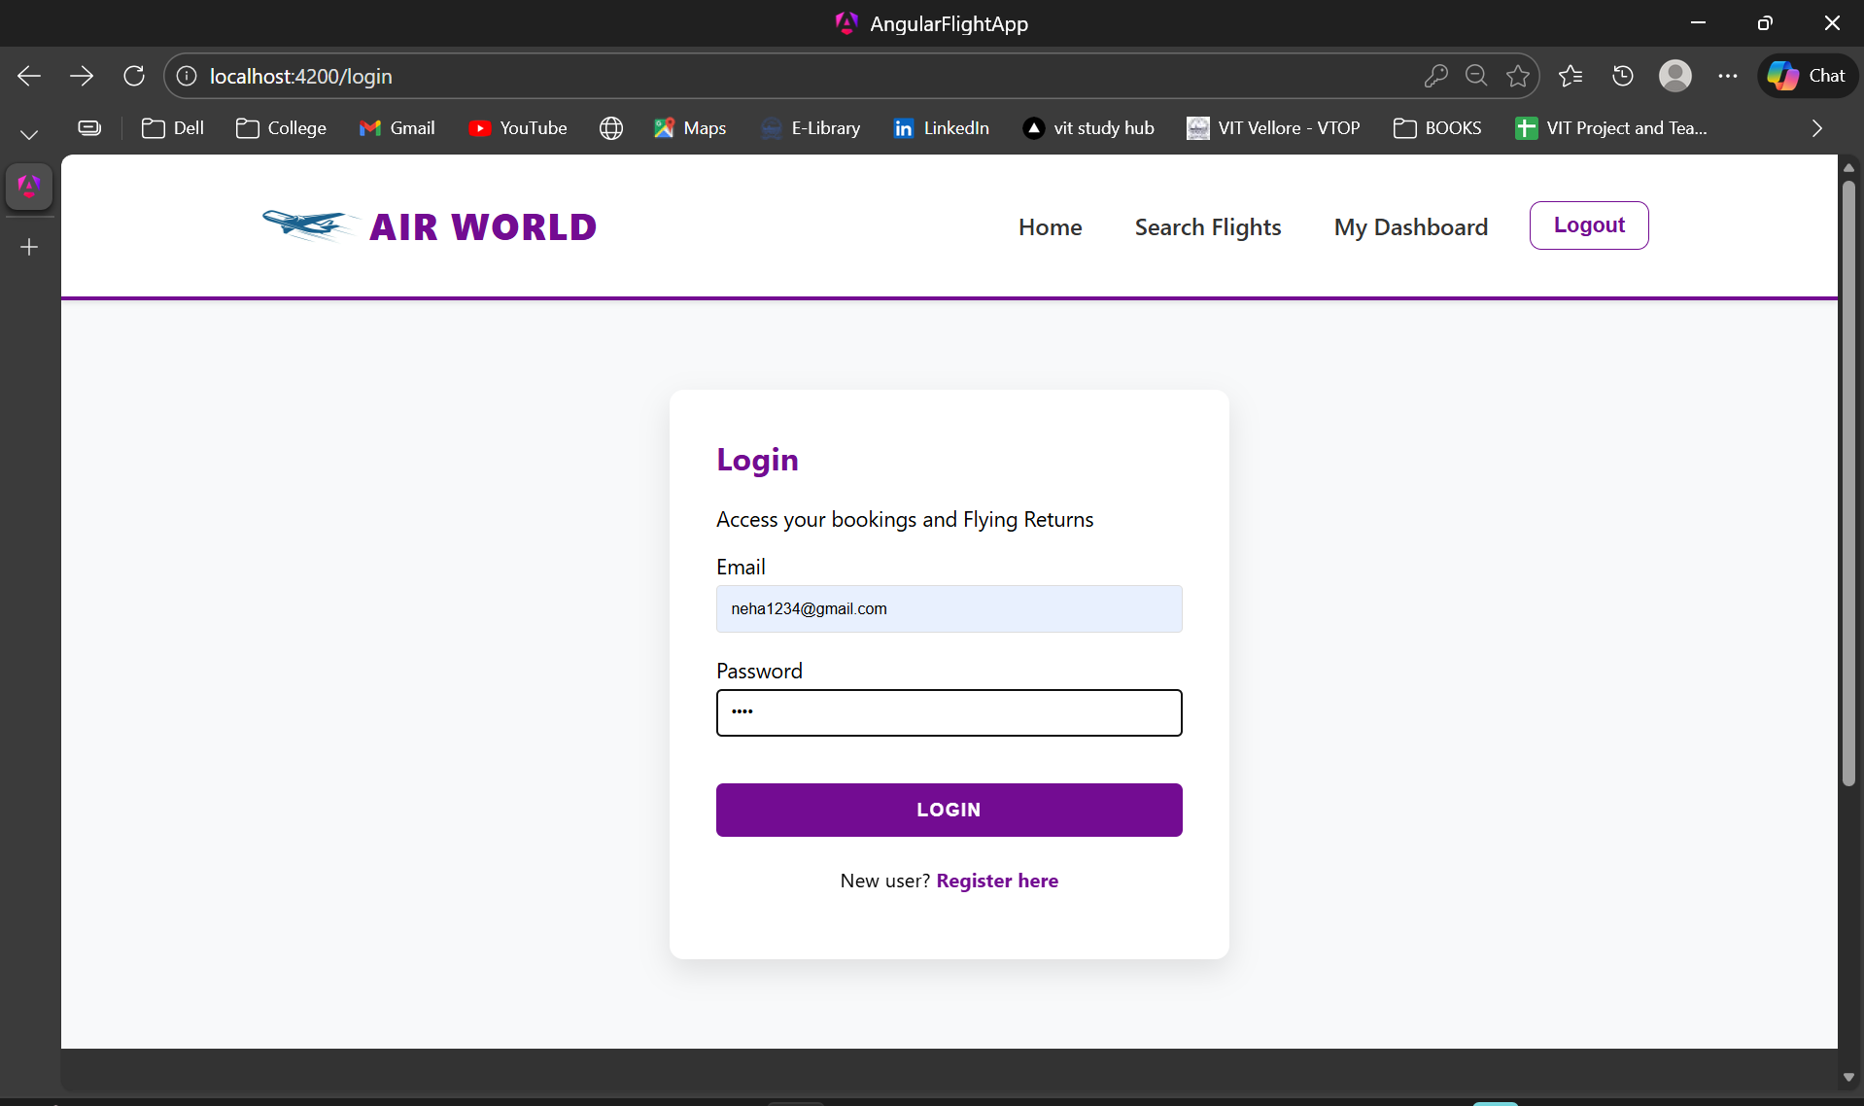

**http://localhost:4200/dashboard**

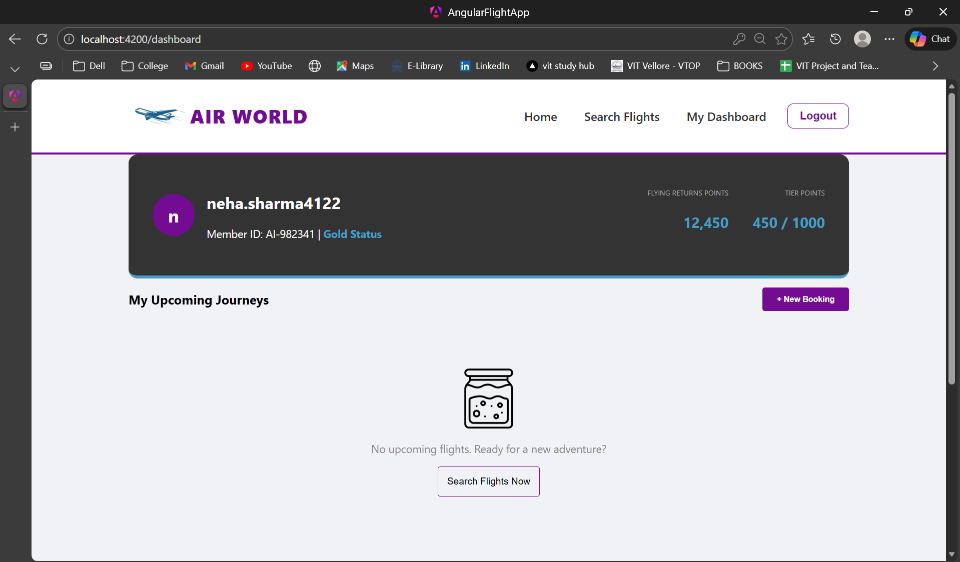

**On clicking New Booking or Search Flights Now:**

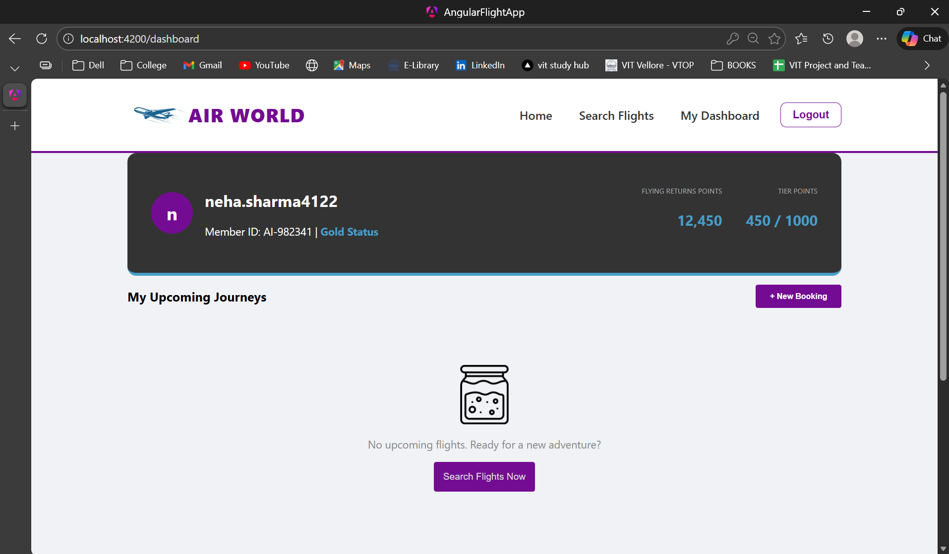

**Redirected to search flights page:**

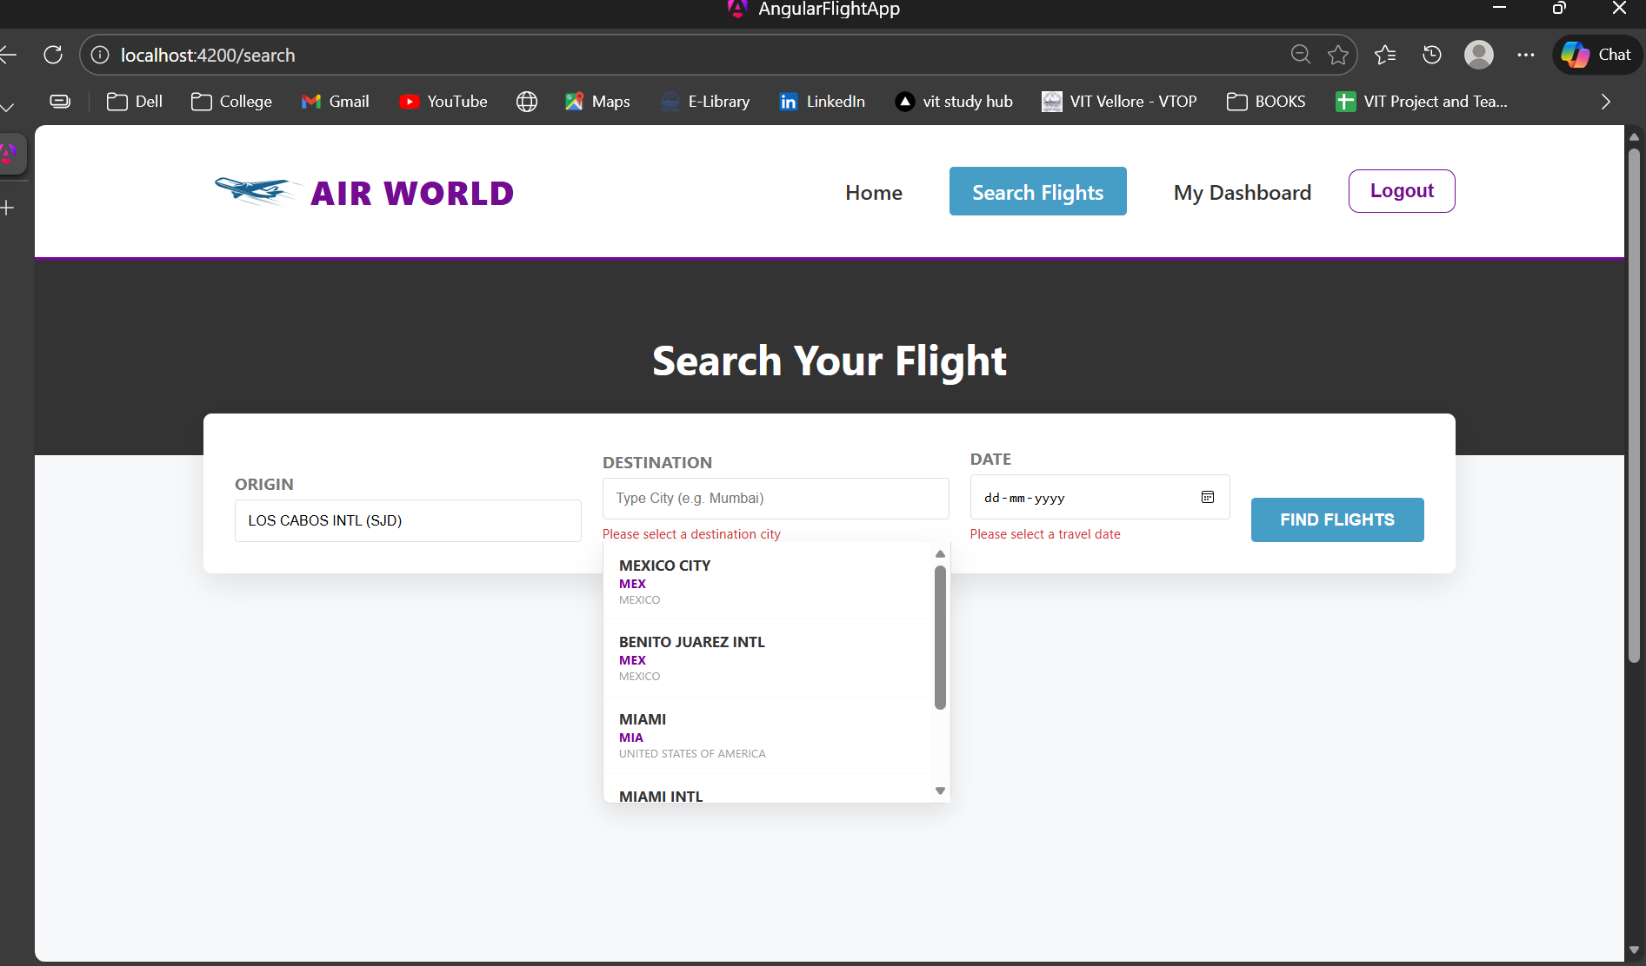

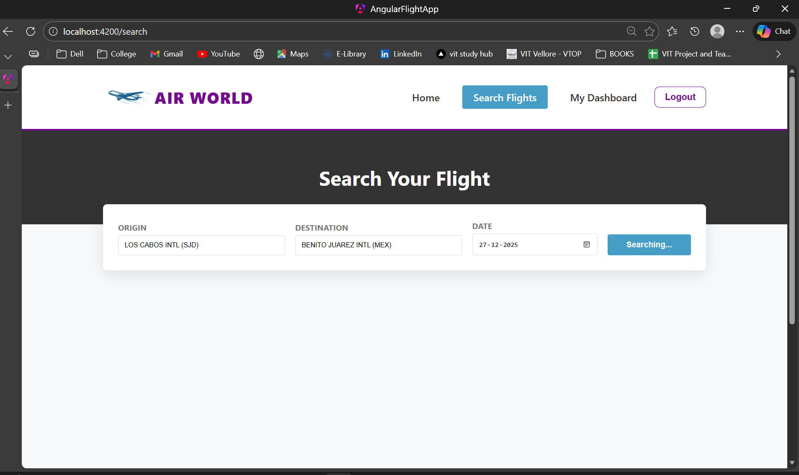

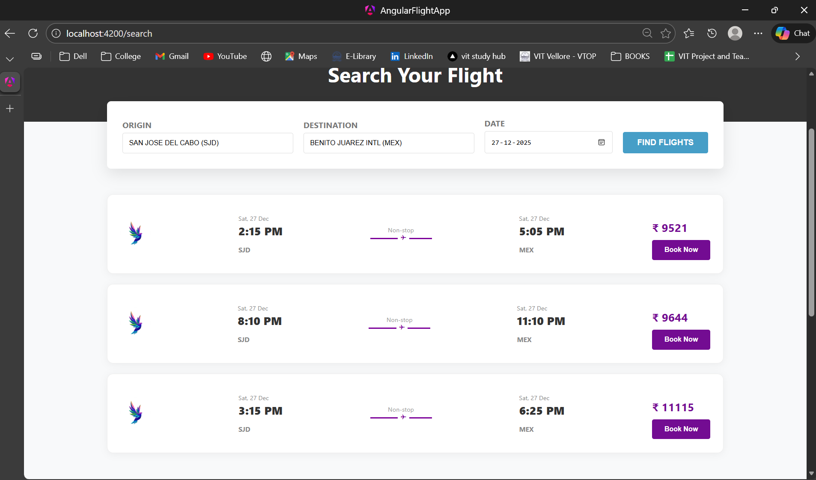

**On clicking “Book Now”:**

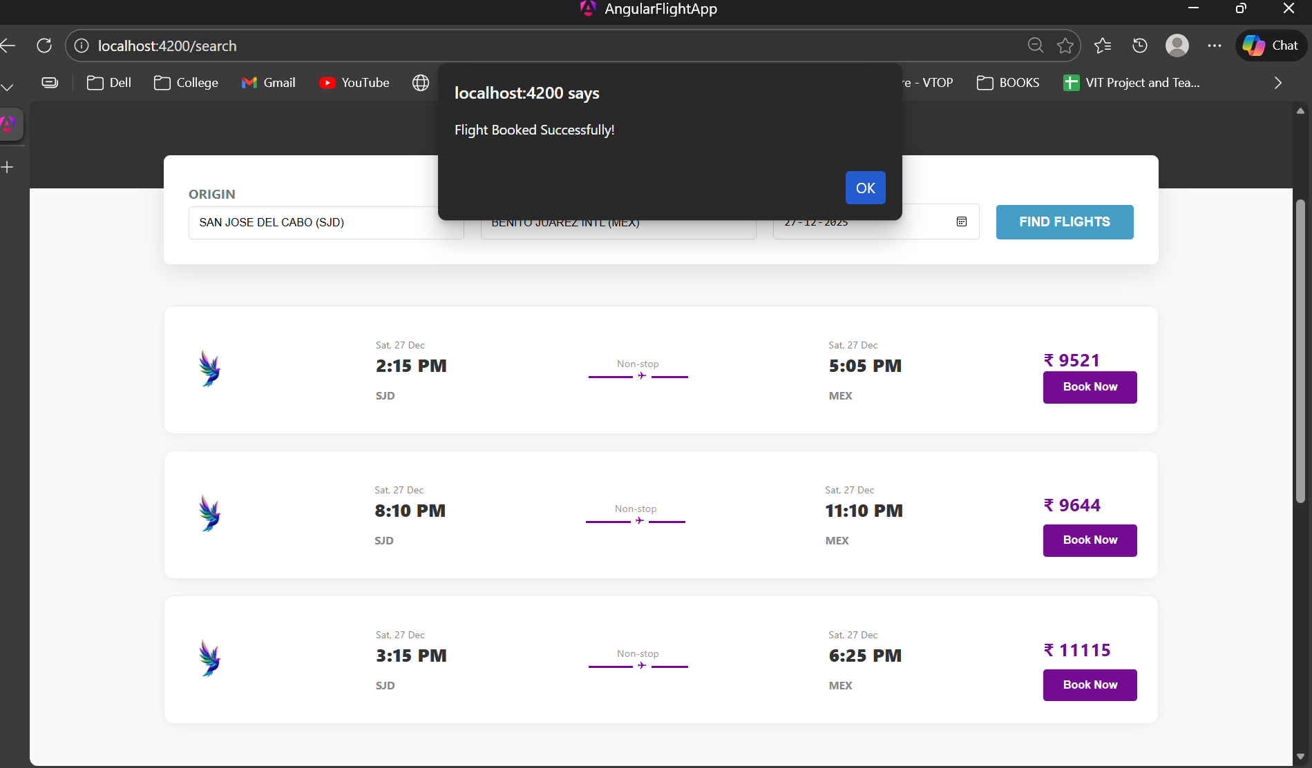

**On clicking "Ok”:**

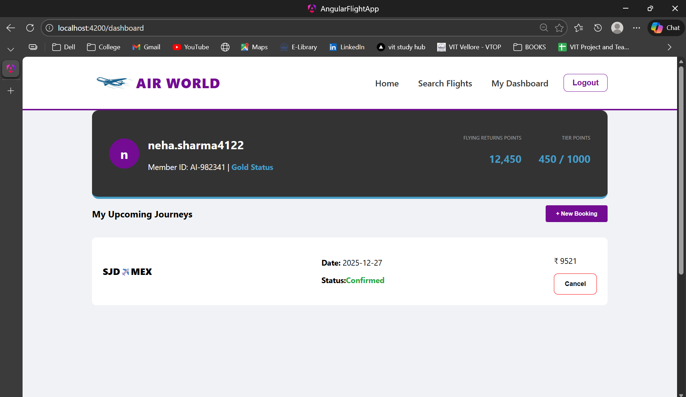

**On clicking “Cancel”:**

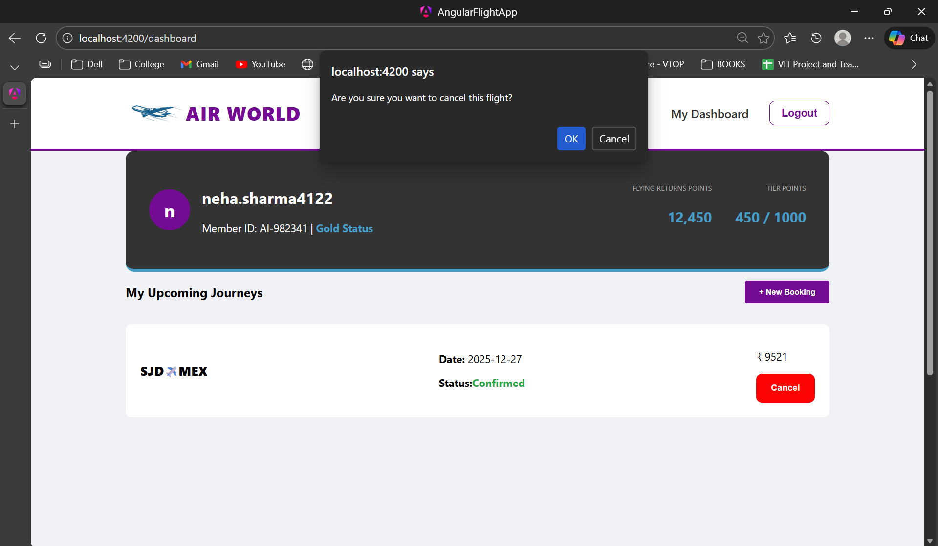

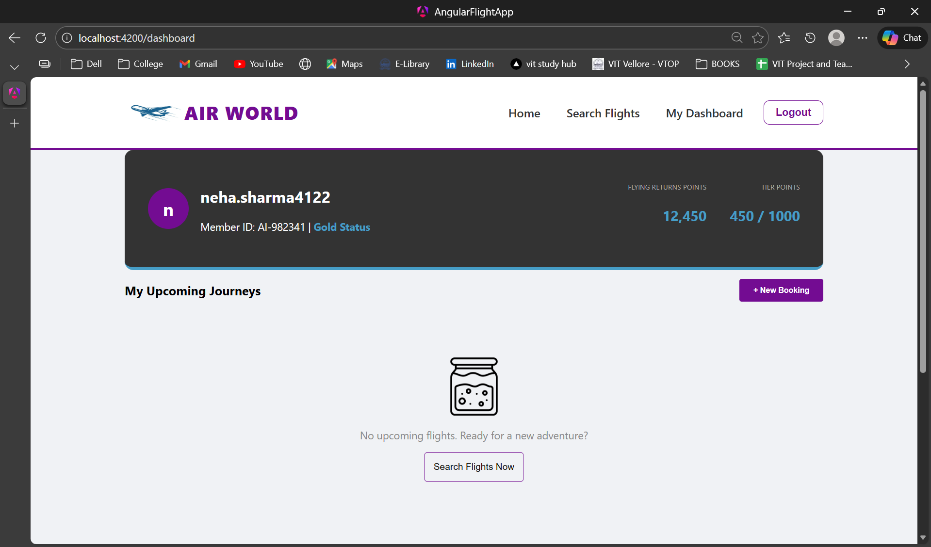

**BACKEND API GATEWAY FOR AUTHENTICATION:**[**https://github.com/NehaSharma4122/FlightApp_Angular_Backend**](https://github.com/NehaSharma4122/FlightApp_Angular_Backend)

**Backend Setup (Mock REST API)**

I have also implemented Backend Setup (Mock REST API) using db.json to check the frontend with dummy data.

